Anderson Serangoon Junior College 2022 JC2 H1 Physics Prelim Mark Scheme

Paper 2

1a | rate of change of velocity | B1
1bi | = 16 m s^{–1}  tan 28° = v_{y} / v_{x}  v_{y} = 16 tan 28°  = 8.5 m s^{–1}  OR  v_{x} = v cos 28° and v_{y} = v sin 28°  v_{y} = 16 x (sin 28° / cos 28°)  = 8.5 m s^{–1} | A1  C1  A1  OR  C1  A1
1bii | Taking upwards as positive,  v = u + at  t = (0 – 8.5) / (–9.81)  = 0.87 s | C1  A1
1biii | Straight line from positive v_{y} at t = 0 to negative v_{y} at t = 1.5 s  Line starts at (0, 8.5) and crosses t-axis at (0.87, 0) and does not go beyond t = 1.5 s.  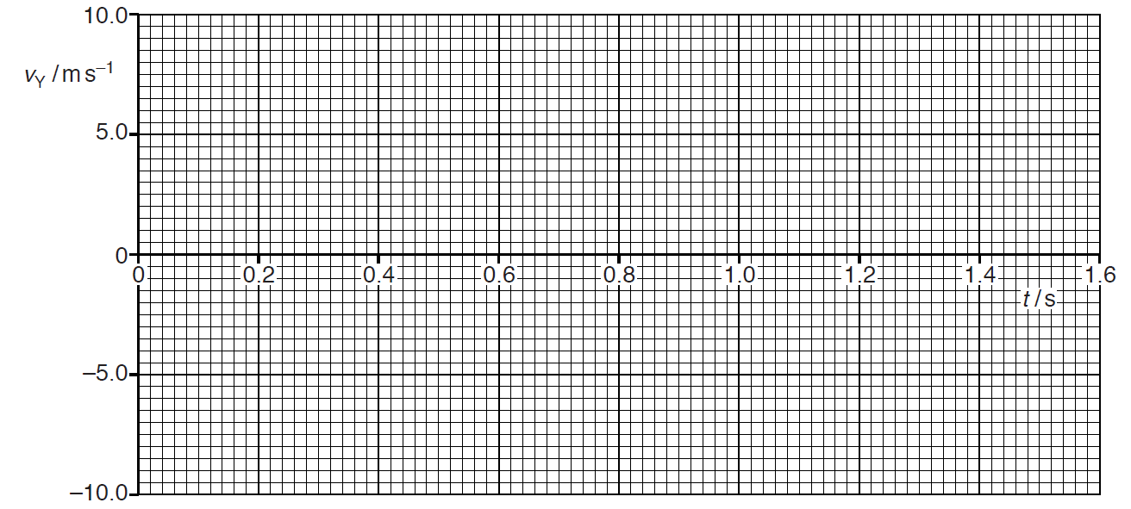 | M1  A1
2a | Equilibrium is a state of a system / body in which it experiences no resultant force  and no resultant torque about any axis. | B1  B1
2bi | Taking moments about the elbow joint | C1  A1
2bii1 | 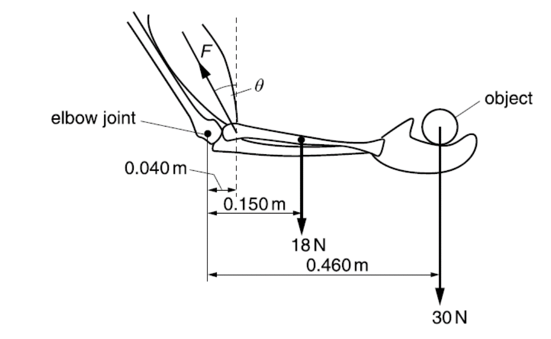  R  Length of R is not a marking point.  R must have a vertical downward component based on magnitude of F and comparison with 18 N and 30 N downward forces.  R must have a rightward component to balance leftward component of F since 18 N and 30 N are both vertical.  (Angle from the vertical should be larger than θ) | A1
2bii2 | The rightward horizontal component of R is to balance the leftward horizontal component of F.  Taking moments about the point the muscle is attached to the bone, the vertical component of R needs to act downwards to provide an anticlockwise moment to counter the clockwise moment provided by the 18 N and 30 N forces.’  OR  ‘The rightward horizontal component of R is to balance the leftward horizontal component of F.  The net vertical force due to the weights and tension is upwards, hence the vertical component of R must act downwards so that there is no net vertical force.’  OR  ‘A vector diagram is drawn in scale.  Using drawn vector diagram in scale, we can deduce the direction of the force R should point rightward and downward.’  OR  ‘The forces of 18 N and 30 N can be combined to form one downwards force which should be drawn between the two mentioned forces.  Since the forces of R, F and combined force due to 18 N and 30 N should intersect at a point, we can deduce the direction of the force R should point rightward and downward.’ | B1  B1  OR  B1  B1  OR  B1  B1  OR  B1  B1
2biii | F increases. | A1
3a | centripetal acceleration = v²/r  = (0.13)²/0.75  = 0.02253 = 0.023 m s⁻² | C1  A1
3b | As the ball moves to the bottom at constant speed, the gravitational potential energy is reduced/ decreases, but the kinetic energy remains constant.  Hence, (negative) work must be done on the ball to maintain constant kinetic energy/ remove energy from system. | M1  A1
3c | work done on stone = ∆ gravitational potential energy  = W × ∆h  = 3.0 × (−1.50) = −4.5 J | C1  A1
3di | point X shown vertically below C (at the bottom of the circular motion path). | B1
3dii | At point of snapping (at the bottom of the circular motion path),  tension from glue  W  tension from glue – W = ma_{c}  18 – 3.0 = (3.0/9.81)(0.75)ω²  ω = 8.087 = 8.1 rad s⁻¹ | C1  C1  A1
4a | Gravitational field strength at Earth’s surface is equal to the acceleration of free fall.  g = $\frac{\text{GM}}{{{\text{R}}_{\text{E}}}^{\text{2}}}$  M = $\frac{{\text{g}{\text{R}}_{\text{E}}}^{\text{2}}}{\text{G}}$ = $\frac{\text{9.8}{\left(\text{6.4×}{\text{10}}^{\text{6}}\right)}^{\text{2}}}{\text{6.67×}{\text{10}}^{\text{-11}}}$  = 6.018 × 10²⁴  = 6.0 × 10²⁴ kg | M1  A1  A0
4b | gravitational force on satellite provides for its centripetal force  F_{net} = ma_{c}  $\frac{\text{GMm}}{{\text{r}}^{\text{2}}}$ = mrω²  r³ = $\frac{\text{GM}}{ω^{\text{2}}}$  r = $\sqrt[\text{3}]{\frac{\text{6.67×}{\text{10}}^{-\text{11}}\text{×6.0×}{\text{10}}^{\text{24}}\text{×}{\left(\text{24×60×60}\right)}^{\text{2}}}{\text{4}{\text{π}}^{\text{2}}}}$  = 42.298 × 10⁶ m  height of satellite = (42.298 – 6.4) × 10⁶  = 36 × 10⁶ m | B1  C1  A1
4c | satellite will already have some speed in the correct direction (thus need lesser fuel) | B1
5ai | By potential divider principle, | C1  A1
5aii1 | Potential difference across XY = 6.4 – 6.0 = 0.4 V | A1
5aii2 | Point Y | A1
5aiii | Current through resistors =  Current through lamps = 0.50 – 0.40  = 0.10 A | M1  M1  A0
5aiv |  | C1  A1
5av | No change to potential difference across lamps and hence (by ), power of lamps unchanged  (Since effective resistance of circuit increases,) total current decreases and so power produced by battery decreases  Ratio increases. | M1  A1
bi | I_{ave} = (1.70 + 1.74 ) /2 = 1.72 mA | A1
bii | Power = IV = 6.00 × (2.00×10⁻³)  = 12 ×10⁻³ W = 12 mW | M1  A0
biii | Correct plotting (up to half the smallest square)  Best-fit curve and smooth curve | A1  B1
biv | Power delivered to load is max when R = r,  From Fig. 5.2, max power occurs when R = 3.0 kΩ  Hence, r = 3.0 kΩ  Accept 2.6 – 3.4 kΩ | A1
6a | Region (of space) where there is a force  either on / produced by magnetic pole  or on / produced by current carrying conductor / moving charge | M1  A1
6b | Correct shape  Correct direction on each line  Field lines are closer nearer to the wire and less dense further away from the wire | B1  B1  B1
6ci | Since the magnetic force is always perpendicular to the velocity / direction of travel of the charged particle, and the speed of the particle does not change,  the charged particle follows a circular path with the magnetic force providing the centripetal force. | M1  A1
6cii | Out of the plane of the paper | A1
6ciii | Electromagnetic force provides centripetal force.  F_{B} = $\frac{\text{m}{\text{v}}_{\text{2}}}{\text{r}}$  Bqv = $\frac{\text{m}{\text{v}}_{\text{2}}}{\text{r}}$  r = $\frac{\text{mv}}{\text{Bq}}$ | B1  M1  A0
6civ | 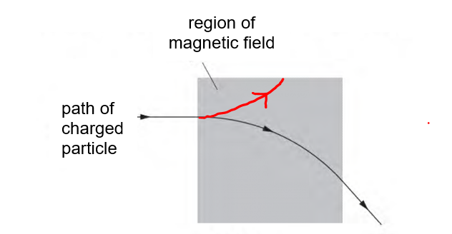 | A1
6di | 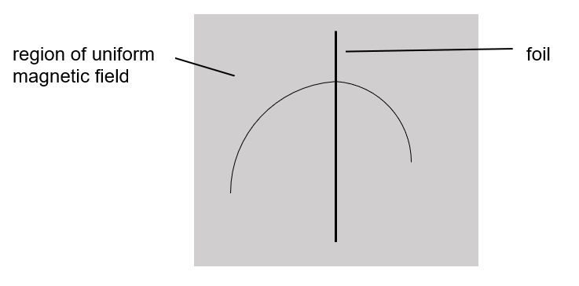  From 6ciii, r is proportional to v, so when the particle loses energy as it passes through the foil, r should reduce, then the particle is moving from left to right side. | A1
6dii | F_{B} = $\frac{\text{m}{\text{v}}_{\text{2}}}{\text{r}}$  Bqv = $\frac{\text{m}{\text{v}}_{\text{2}}}{\text{r}}$  Bqr = mv  OR  From Q6ciii  r = $\frac{\text{mv}}{\text{Bq}}$  Hence momentum is proportional to the radius.  $\frac{\text{final momentum of particle}}{\text{initial momentum of particle}}$ = $\frac{5.7}{7.4}$  = 0.77  (must be consistent with the direction drawn in di) | C1  A1
7a | The rate of change of momentum of a body is proportional to the resultant force acting on the body  and takes place in the direction of the resultant force. | B1  B1
7bi | The acceleration of object X is dependent on the resultant of the two forces, weight and tension, acting on object X. Since the weight and tension are in opposite directions, the resultant force must be less than its weight and hence, has an acceleration less than g. | B1
7bii | Let T be the tension in the rope.  Considering the FBD of object X, by N2L,  ↓+: m_{X}g – T = m_{X}a  T = m_{X}g – m_{X}a ………. (1)  Considering the FBD of object Y, by N2L,  ↑+: T – m_{Y}g = m_{Y}a  T = m_{Y}g + m_{Y}a ………. (2)  Equating (1) and (2), we have  m_{X}g – m_{X}a = m_{Y}g + m_{Y}a  g (m_{X} – m_{Y}) = a (m_{X} + m_{Y})  Hence, | M1  M1  A1
7biii | Since the motion is linear with uniform acceleration,  using s = ut + ½ at²  ↓+:  t = 1.749 s = 1.7 s | C1  A1
7c | According to Newton’s 3rd Law, F₁₂ = −F₂₁ … (1)  Taking the time of collision to be t,  Using Newton’s 2nd Law, eqn (1) can be rewritten as,  OR  OR | B1  M1  A1
7di | Since total momentum is conserved, when Q gains momentum (positive gradient), P loses momentum (negative gradient).  Hence, the gradients of the graphs must have opposite sign.  OR  Gradient of the graph is the net force acting on the object. Since the 2 forces are action-reaction pair, hence they must be opposite direction. | B1
7dii | When there is no net (or resultant) external force acting on the system. | B1
7diii | Total initial momentum = 20 + 16 = 36 kg m s⁻¹  Total final momentum = 24 + 12 = 36 kg m s⁻¹  Total momentum is conserved. | A1
7div | Force acting on body P = rate of change of momentum of body P  =  = −26.7 N = −27 N  Magnitude of force = 27 N | C1  A1
7dv | Impulse = F t = 26.7 × 150 × 10⁻³ = 4.0 N s  OR  Impulse = change in momentum = 24 – 20 = 4.0 N s | A1
7dvi | Relative speed of approach =  Relative speed of separation =  RSS is not equal to RSA, and RSS is zero, so the collision is perfectly inelastic. | B1  B1  A1
8a | Most α-particles have little or no deflection.  A small fraction of α-particles deviated through small angle (more than about 10°), and a very small fraction deviated through large angle more than 90°. | A1  A1
8b | Nuclear Fission is the splitting of a nucleus of high nucleon number into two smaller nuclei of approximately equal mass with the release of energy and neutrons. | A1
8ci | Mass defect  = [7(1.007276) + 7(1.008664)]u – 14.007525u  = 0.104055u  Binding energy  = mass defect x c²  = 0.104055u x (3.00 x 10⁸)²  = 1.5545817 x 10⁻¹¹ J  Binding energy per nucleon  = Binding energy / no. of nucleons  = 1.5545817 x 10⁻¹¹ / 14  = 1.1104155 x 10⁻¹² J  = 1.11 x 10⁻¹² J | C1  C1  A1
8cii | As oxygen–17 has a higher binding energy per nucleon, it is more stable. | A1
8ciii | Change in mass ∆m  = mass of product – mass of reactants  = [(17.004507 + 1.008142) - (14.007525 + 4.003860)]u  = 1.264 x 10⁻³u  = 2.09824 x 10⁻³⁰ kg  Change in rest-mass energy  = ∆mc²  = 2.09824 x 10⁻³⁰ (3.00 x 10⁸)²  = 1.888 x 10⁻¹³ J  = 1.9 x 10⁻¹³ J | C1  C1  A1
8civ | The increase in mass as shown in calculation in (c)(iii) implies that energy has been converted to mass.  Hence, the reaction is only possible if the alpha particle has kinetic energy that is at least equal to the value calculated in (c)(iii), which can be converted into mass. | M1  A1
8cv1 | Based on conservation of momentum, as the total initial momentum is not zero, since alpha particle is moving and nitrogen–14 is stationary, final momentum cannot be zero and hence the product particles must have kinetic energy after the reaction. | A1
8cv2 | So, the alpha particle needs to have more kinetic energy than 1.9 x 10⁻³⁰ J, so that while some of the kinetic energy is converted to mass, there is sufficient kinetic energy left to move the product particles. | A1
8d | Random decay means the nucleus has constant probability of decay per unit time. There is no way to predict when any individual nucleus will decay.  Spontaneous decay means the decay occurs on its own and is unaffected by environmental or external factors such as temperature and pressure.  (Must include at least one factor for full credit) | B1  B1
8ei |  | A1
8eii | The number of La−140 will decrease exponentially with time due to decay.  The number of Ce−140 will increase by the same amount as the decrease in La−140 and the number will not decrease since Ce−140 is stable.  The two graph should intersect at 40 hours when at 0.5 N₀ is halved since the half-life is 40 hours.  N  t / hours  0  N₀  Ce  La  0.5N₀  40 | B1  B1  B1

